DWA 219:
Democracy and Development in South Asia
Spring 2025

Professor ShahBano Ijaz Class Days: M/W
Pronouns: she/hers Class Hours: 7:15–10:10 p.m.
Email: ijaz@oxy.edu Location: Fowler 201
Office: Johnson Hall 208
Office Hours: Wednesdays 9:30 a.m. – 11:30 p.m. (and by appointment over email/Zoom).
Please sign up here for Wednesday office hours.

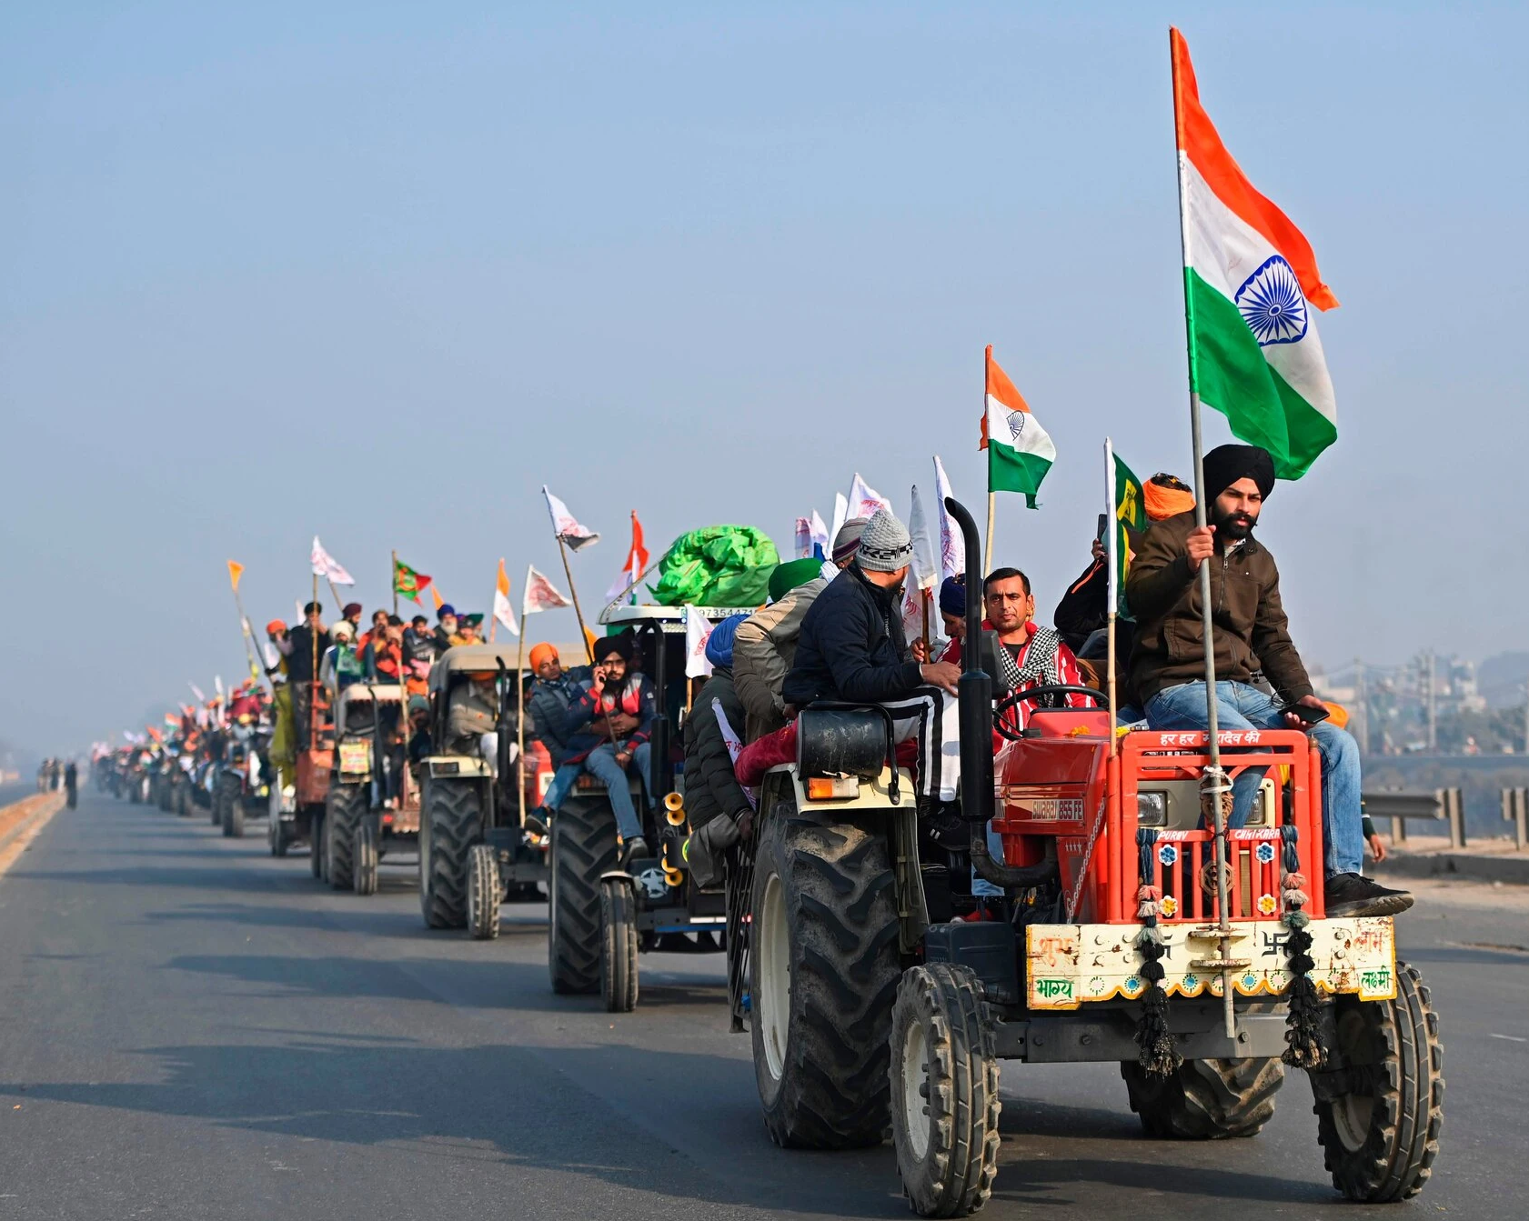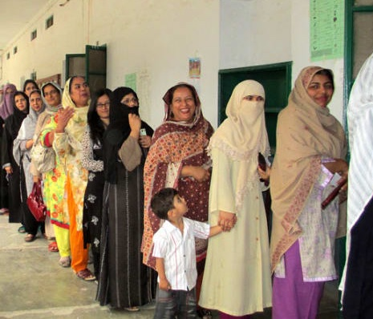

Course Description:

This class introduces students to the study of South Asian politics. It uses seminal and contemporary scholarship in political science to demonstrate the similarities and differences in the how politics is conducted across South Asia and the western world. The course offers a comprehensive introduction to the comparative politics of the region, with a focus on four key characteristics: the colonial legacy in shaping South Asian political institutions, the intraregional relationships including those that have escalated to violent conflict and war, the political economy of development, micropolitical processes that shape democratic outcomes and the future of democracy in the region. A core objective of the course is to offer insights on how politics proceeds in non-Western contexts and develop an appreciation of alternative models of democracy that emphasize people-to-people contact rather than legislative performance. By the end of the course, students will be able to define and explain phenomenon that define South Asian politics and other developing democracies, such as: constituency service, corruption, vote-buying and dynastic parties. At an affective level, students will develop an understanding of the political processes in South Asian countries and appreciate the underlying conditions that give rise to adapted versions of accountability that are not necessarily comparable to democratic manifestations in Western countries.

Learning Objectives and Goals:

The course materials and assignments are designed to help students achieve the following learning goals:

- Students will develop an understanding of South Asia as a historical region, and its politics post colonization.
- Students will be able to identify the core concepts that define the politics of South Asia, and of the developing world more broadly.
- Students will have a comprehensive understanding of seminal and contemporary research on South Asian politics, and understand how to construct and propose their own research on the region.
- Students will learn how to construct clear arguments, and challenge the ones presented in syllabus readings.

Required Readings

All required readings include articles and books chapters, will be made available in PDF format on Canvas. Where a PDF is not available there will be a link to the website where students can access the reading.

Some readings are available electronically on the Oxy Library website. You will need to create a (free) Open Library account to view them.

Recommended books:

There are no textbooks assigned for the class; following is a list of broadly accessible books that focus on the study of South Asian Politics:

- Routledge handbook of South Asian Politics: India, Pakistan, Bangladesh, Sri Lanka and Nepal. (2010) Ed. by Paul Brass. Routledge London and New York.
- Guha, Ramachandra. (2019). India After Gandhi: The History of the World’s Largest Democracy. Harper Collins Publishers.
- Jalal, Ayesha (1994). The Sole Spokesman: Jinnah, the Muslim League and the Demand for Pakistan. Cambridge University Press.
- Lewis, David (2011). Bangladesh: Politics, Economy and Civil Society. Cambridge University Press.
- Wickramasinghe, Nira (2014).Sri Lanka in the Modern Age: A History. Oxford University Press.

To keep up with the news, here is a list of helpful newspapers and other media sources:

- India: Times of India; The Hindu; Indian Express (See especially the regular columns by Pratap Bhanu Mehta and Ashutosh Varshney.
- Pakistan: Dawn; Newsline
- Bangladesh: Daily Star; New Age
- Sri Lanka: Daily News; The Island
- Podcasts: How To Pakistan; The Seen and the Unseen; Incarnations: India in 50 Lives; In the Field Focuses on development issues in India; Indian Express: Adda In-depth interviews with prominent Indian politicians; Centre for Policy Research: Thoughtspace; Center for Economic Research in Pakistan.

Course Requirements:

Assignment | Weight | Due Date
Attendance / Participation | 15% | In class participation / ongoing
News Commentaries (2) | 20% | First Commentary: due February 12th at midnight  Second Commentary: due March 11th at midnight
Review Essays (2) | 20% | First Review Essay: due February 19th at midnight  Second Review Essay: due March 18th at midnight
Final paper proposal | 10% | Due April 9th at midnight
Peer Review | 10% | Due April 23rd at midnight
Final paper | 25% | Due May 8th at midnight

Attendance:
Attendance is mandatory; however, COVID continues to pose a threat to our health. If you are not feeling well, or if you have had close contact with someone who is sick or has tested positive for COVID-19, please do not come to class. Send me an email letting me know you will be absent, and I will help you access the material you missed. You will not be penalized for missing class due to illness or quarantine.

Participation:
As a seminar, this course should be driven more by student participation than by the professor. We will take this principle seriously, which means:
- Students are expected to attend class having completed all the required readings for that day. You will be expected to actively participate in any peer review exercises, online discussion forums, group projects, etc. If you encounter circumstances that prevent you from participating in these ways, please contact me and we can discuss alternative forms of participation if needed.
- No readings in this class are voluntary: please expect to be called upon to summarize the reading, present a recap of it or share the core arguments.
- Students will be assigned to lead a discussion of one or more readings. You will be expected to both present on the importance of a particular reading, the specific questions it raises, and to stimulate a critical discussion of that reading. Some questions you can keep in mind as you prepare to lead the discussion include:
  - What is the key question raised in the reading?
  - What is the author’s thesis?
  - What argument does the author use to support the thesis?
  - What are the counterarguments the author provides in defense of their thesis?
  - What is at stake in the argument, i.e., why should we care?
A useful exercise to do is to graph or draw out the argument of the author. We will discuss doing this in class, and I will encourage you to share your drawings with the class when you’re leading the discussion.

I encourage you to consult with me during the semester if you want to know about or improve your participation grade.

Review Essays (10% each; 20% total):
Choose a set of readings from the class (of your choice) and write an opinionated review essay covering 4-5 pages. The essay should address the following:
- Identify and discuss the author’s key research question, thesis and argument in support of that thesis.
- Draw connections between the readings (either within the set of readings that you have chosen or with another set/topic of readings you have covered for the class). These connections should help you to identify where the readings you are reviewing are situated in the broader development literature, and what their significant contribution to the literature is.
- Develop and share your independent argument based on the initial set of readings and the connections you draw. This is the most important aspect of the review essay and an opportunity to display your intellectual originality and engagement with the topic.

News Commentary (10% each; 20% total):
At the start of the course, you will be asked to choose a country (if you are from a country in South Asia, or have family in a country, you will be asked to choose a different country: the goal is to learn new things!) You will be asked to submit two news commentaries (~300 words each) during the semester. For each news commentary, do the following:
- Choose a news article about a recent political or economic event in your assigned country.
- The event should have occurred not more than a month ago at the time of submission.
- Include a link to the news article at the top of your commentary.
- Describe in no more than 300 words how the event relates to one or more of the topics we have discussed in class. The goal is to demonstrate that you can view current affairs
through an analytic lens, and see how events relate to broader trends or theories.
- Do not include a bibliography or any footnotes.

Proposal, Paper and Presentation (10%, 10%, 25%):
The final paper (7 – 9 pages, approximately 2000-2500 words) will be predicated by a proposal (1-2 pages) and a presentation (approx. 5-7 minutes in class). The purpose of the final paper is to develop a preliminary research idea related to the politics of South Asia, that can potentially translate into a senior comps project. Handouts will be provided during the class to guide your thinking in developing the proposal, the presentations and the paper.

Laptops:
Laptop use is strictly prohibited in-class. Studies show that laptops create “zones of distraction” in class and lower the grades of students nearby as well as those using them. Students using laptops also tend to produce inferior notes that do not digest and restate lecture materials as effectively as handwritten notes. If you have a medical or physiological reason to need laptop access during lectures and discussions, please see me in person after class or during my office hours.

Time commitment: This is a 4-unit course. It is expected that students in this class will be devoting at least twelve (12) hours a week (including in-class time) on average to the class.

Core Program Requirements: DWA 103 also fulfills the Core Program Requirements and counts toward the Core Program Global Connections requirements.
Grading Criteria:

A: Demonstrates superior mastery of the course content in written work, class participation, and presentations. Papers demonstrate advanced research and writing skills, including original arguments, and integration of academic sources, and are free of errors. Exams and papers exceed the minimum expectations for the course.

B: Demonstrates a good command of the course content. Written work shows above-average effort, strong critical thinking skills, the ability to develop and defend an argument, and a willingness to go beyond the minimum requirements of the assignment or exam questions.

C: Demonstrates a satisfactory command of the course content. Written work and exam performance meet the minimum requirements for the class. Papers are of average or below-average quality in terms of content and editing. Missed deadlines and/or frequent absences can result in a C grade.

D: Meets bare minimum requirements for passing the class. Frequent absences, late assignments, and limited command of course material.

F: Students who receive an F have not met the minimum requirements for passing the class.

Grade distribution:

A | A- | B+ | B | B- | C+ | C | C- | D+ | D | F
93.5 | 90 | 87.5 | 85 | 80 | 77.5 | 72.5 | 70 | 67.5 | 60 | 0-63

How to succeed in this class:

- Read and take notes on assigned texts before each class meeting. Each class has a reading assignment that you should complete prior to coming to class. The schedule of what to prepare for each day is at the end of the syllabus.
- Attend every class prepared to learn. Attending class in person is the most effective way to learn the content (versus reading borrowed notes).
- Take good notes on lectures, discussions, and readings. I will often use PowerPoint as a visual outline for the lecture, but they will include only a bare outline of the material. You will not pass the class if you study only from the PowerPoint lecture notes! Instead, you should take notes that identify the main points and supporting examples in your own words.
- Communicate, communicate! If you have any doubts about what the course requires of you, or if you are not receiving grades as high as you expect, please don’t hesitate to contact me. It will be important to address any problems early when there is still time to make a plan to improve your grade. If you wait until the end of the semester, there will be fewer options for improving your performance in the class.

Mid-Semester Progress Reports
All faculty are encouraged to provide students with a mid-semester progress report for every course. Mid-semester progress reports are not intended to be used as determinative or predictive of the final grade in a course, but to provide an opportunity for the faculty to communicate an approximate estimation of progress by the students in the course by the midpoint of the current semester.

Course Policies:

Masks:
Your health and well-being, and that of our community, are essential. Since COVID-19 continues to pose a threat to many of us, students are encouraged, but not required, to wear masks in class – KN95, N95, or surgical masks are best. Please use your best judgment to wear a mask, especially if you have been in close contact with someone who has tested positive for COVID-19. If you are feeling any symptoms of illness, please refrain from attending class until you receive a negative COVID test or it has been 10 days since your symptoms began. Please work with Emmons and the COVID Operations team to confirm when and how you can end your isolation. Similarly, if you have been identified as a close contact of someone who has tested positive for COVID-19, please follow all applicable College policies, and wear a high-quality mask when around other individuals for 10 days.

Communication:
Check your registered campus email regularly as well as announcements made to the Moodle site for the course. You are responsible for the material I send you electronically. I will respond to your email inquiries within 24 hours during weekdays, and on the first weekday if you email me after 5 p.m. on Friday (or over a break).

Class Recordings:
No recording of classroom instruction is permitted. The sharing, altering, or distorting of any audio-visual capture of a class session is not permitted. All content contained in the records shall be subject to the College’s Policy on Intellectual Property.

Late Assignments:
Late work will be docked 1/3 of a letter grade for each day the assignment is late beginning after the assignment is collected. If a medical, legal, or family emergency causes you to miss class, or an assignment deadline, or if an emergency affects your sustained engagement with the course, please reach out to me as soon as possible. If you do not feel comfortable sharing the specifics of your situation, please let me know the broad contours of your situation and we can work to arrange appropriate accommodations. I will ask you to reach out to the Dean of Students, who can communicate any necessary accommodations to me.

Syllabus Change:
In the interest of flexibility, I may need to make small changes to the syllabus throughout the semester – but I will not add any required assignments or readings.

Statement of the Shared Academic Integrity Commitment:

Academic Integrity is a shared community value. It is built around trust and respect between members of the Occidental Community and embodies a commitment to honesty and integrity in every aspect of one’s academic life.

All members of the Occidental community are committed to upholding the highest degree of academic integrity. Unless stipulated otherwise, the academic work done for all assignments is expected to be the student’s own; students are expected to give proper credit to the ideas and work of others.

Signing the Academic Integrity Commitment at the beginning of every semester represents a student’s affirmation to uphold the shared values of honesty and integrity. When signing the Integrity Commitment associated with work in a course, students are affirming that they have not cheated, plagiarized, fabricated, or falsified information; nor assisted others in these actions.

For more information, please see this link to Student Handbook.

Civil Rights & Title IX statement, and statement of role of faculty member as a mandatory reporter:

In the event that you write or speak about having experienced discrimination or harassment on the basis of a protected characteristic or sexual misconduct (including sexual assault, dating/domestic violence, stalking, sexual exploitation or any other form of sexual and/or gender-based harassment), as a designated Responsible Employee, I must inform the Civil Rights & Title IX Office. They will contact you to let you know about resources and support services at Oxy, as well as reporting options both on and off-campus. You have no obligation to respond to the Civil Rights & Title IX Office or to meet with them to discuss support services and reporting options.

If you do not want the Civil Rights & Title IX Office contacted, instead of disclosing this information to your instructor, either through conversation or a class assignment, you can speak confidentially with:
- Oxy's Survivor Advocate, Project SAFE (survivoradvocate@oxy.edu)
- Emmons Counseling (For appointments, call: 323-259-2657)
- Rev. Dr. Susan Young, Office of Religious and Spiritual Life (young@oxy.edu)
- Oxy 24/7 Confidential Hotline (323-341-4141)

The College’s civil rights policies, along with additional resources, can be found at: https://www.oxy.edu/civil-rights-title-ix. If you would like to contact the Civil Rights & Title IX Office directly, you may email Civil Rights & Title IX Coordinator Alexandra Fulcher at afulcher@oxy.edu or call 323-259-1338.

Special Accommodations/Learning Differences:
All academic and housing accommodation requests are managed by Disability Services & Student Support (DSSS). It is a student’s responsibility to contact DSSS if they need accommodations or additional support. Any student who has, or thinks they may have, a physical, learning, or psychological disability may contact Disability Services at accessibility@oxy.edu to learn about available services and support. More information is available at http://www.oxy.edu/disability-services.

Accommodations for Reasons of Faith and Conscience:
Consistent with Occidental College’s commitment to creating an academic community that is respectful of and welcoming to persons of differing backgrounds, we believe that students should be excused from class for reasons of faith and conscience without academic consequence. While it is not feasible to schedule coursework around all days of conviction for a class as a whole, faculty will honor requests from individual students to reschedule coursework, to be absent from classes that conflict with the identified days. Information about this process is available on the ORSL website:https://www.oxy.edu/student-life/resources-support/orsl/academic-accommodations.

Discrimination, Harassment, and Retaliation policy:
I strive to foster an inclusive classroom environment. Consistent with College policy on discrimination, harassment, and retaliation, I seek to maintain an environment of mutual respect among all members of our community. Please come to me with any concerns.

Land Acknowledgement:

Occidental College occupies the traditional territory and homelands of the Tongva people. Please click through to read more about the Gabrielino-Tongva tribe and about the practice of land acknowledgement

Date | Topics | Readings | Public Scholarship | Assignments Due
Week 1 | Political Institutions and Colonial Legacy in South Asia
Wednesday January 22nd |  | - Syllabus  - Jalal, Ayesha(1994). The Sole Spokesman: Jinnah, the Muslim League and the Demand for Pakistan. Cambridge University Press. Chapter 2.  - Metcalf, Barbara D and Thomas R Metcalf (2006). A Concise History of Modern India. Cambridge University Press. Chapter 7.  - Ludden, David (2011), “The Politics of Independence in Bangladesh”, Economics and Politics Weekly, 46(35): 81-85.  - Guha, Ramachandra (2011). India After Gandhi: The History of the World’s Largest Democracy. Pan  Macmillan. Chapters 1 and 2. | - Mir, Asfandyar. (2019). “The Kashmir Attack could prompt a crisis in South Asia. Here’s Why,” The Monkey Cage in The Washington Post.  - Koirala and MacDonald (2015). “Nepal is in crisis, and it has nothing to do with the earthquake: Here’s what you need to know,” The Monkey Cage in The Washington Post. | Sign up for Discussion Leaders here
Week 2 | Interregional Relationships in South Asia 1: Civil Conflict & War
Wednesday January 29th |  | - Brass, Paul R (2011). The Production of Hindu-Muslim Violence in Contemporary India. University of Washington Press. Chapter 1.  - Sexton, Renard (2016). “Aid as a Tool Against Insurgency: Evidence from Contested and Controlled Territory in Afghanistan,” American Political Science Review.  - Staniland, Paul (2013). “Kashmir since 2003: Counterinsurgency and the Paradox of Normalcy,” Asian Survey, 53(5):931–957. | - Cronan-Furman, Kate. (2019). “What happened in Sri Lanka? Here’s what you need to know,” The Monkey Cage in The Washington Post.  - Movie: Haider (for Netflix users) / Born to Fight on YouTube
Week 3 | Climate Change in South Asia
Wednesday February 5th |  | - Gulzar, Saad; Apoorva Lal and Benjamin Pasquale. "Representation and Forest Conservation: Evidence from India’s Scheduled Areas." American Political Science Review (2023): 1-20.  - Haider, Erum, “The Politics of Privatized Service Delivery: South Asia & Beyond,” Georgetown Journal of Asian Affairs. (2024)  - Haider, Erum; Siddiqui, Niloufer, “Votes for Water: Ethnic Service Delivery and Criminality in Karachi, Pakistan,” Studies in Comparative International Development (2024). | - Esther Duflo, Rema Hanna and Michael Greenstone, “Improved cooking stoves in India: Evaluating long-run impacts,” VoxDev. 2021.
Week 4 | Islamist Violence and Terrorism in Pakistan |  |  | First News Commentary due on February 12th at 11:59p.m.
Wednesday February 12th |  | - Blair, Graeme, C Christine Fair, Neil Malhotra and Jacob N Shapiro (2013). “Poverty and support for militant politics: Evidence from Pakistan”. In: American Journal of Political Science 57.1, pp. 30–48.  - Siddiqui, Niloufer (2022). “Political Parties and Violence in Karachi, Pakistan,” Comparative Political Studies, 56(5).  - Ullah, Haroon K (2013). Vying for Allah’s Vote: Understanding Islamic Parties, Political Violence, and Extremism in Pakistan. Georgetown University Press. Chapter 2. | - Humayun, Fahd (2021). “5 ways the Taliban takeover in Afghanistan will hurt Pakistan,” The Monkey Cage in The Washington Post.  - Siddiqui, Niloufer (2017). “What is behind the Islamist protests in Pakistan?” The Monkey Cage in The Washington Post.  - Movie: Khuda Ke Liye
Week 5 | The Rise of Hindu Nationalism in India |  |  | First review essay due on February 19th at 11:59 p.m.
Wednesday February 19th |  | - Brass, Paul R (1997).Theft of an Idol: Text and Context in the Representation of Collective Violence. Princeton University Press. Chapter 7, “Kala Bachcha: Portrait of a BJP Hero.”  - Jaffrelot, Christophe (1999). The Hindu Nationalist Movement and Indian Politics: 1925 to the1990s. Penguin Books. Chapter 11, “The Making of a Hindu Vote?”  - Varshney, Ashutosh; Ayyangar, Srikrishna and Siddharth Swaminathan. (2021) “Populism and Hindu Nationalism in India,” Studies in Comaprative International Development, 56:197-222. | - Kapur, Devesh (2019). “The Indian prime minister and Trump addressed a Houston rally. Who was signaling what?” The Monkey Cage in The Washington Post.  - Marvel, Ishan (2016). “In the Name of the Mother: How the State Nurtures the Gau Rakshaksof Haryana”. In:Caravan Magazine. September  - Movie: Firaaq
Week 6 | Nuclear Politics in South Asia
Wednesday  February 26th |  | - Clary, Christopher; Lalwani, Sameer, and Niloufer Siddiqui. (2021). “Public Opinion and Crisis Behavior in a Nuclearized South Asia,” International Studies Quarterly, 65(4): 1064-1076.  - Narang, Vipin (2010). “Posturing for Peace? Pakistan’s Nuclear Postures and South Asian Stability”. In: International Security 34.3, pp. 38–78.  - Kapur, S Paul (2005). “India and Pakistan’s Unstable Peace: Why Nuclear South Asia Is Not Like Cold War Europe”. In: International Security 30.2, pp. 127–152. | - Humayun, Fahd. (2020). “After India’s skirmish with China, is Pakistan next?” Foreign Policy.  - Optional videos: Stimson Open Online Course—Nuclear South Asia.
Week 7 | Political Economy and Development – I
Wednesday March 5th |  | - Gulzar, Saad and Ben Pasquale. (2017). “Politicians, bureaucrats and development: Evidence from India,” American Political Science Review, 111(1): 162-183.  - Khan, Adnan Q., Asim Ijaz Khwaja, and Benjamin A. Olken. (2019). “Making Moves Matter: Experimental Evidence on Incentivizing Bureaucrats through Performance-Based Postings,” American Economic Review, 109(1): 237-270.  - Bussell, Jennifer. Clients and Constituents: Political Responsiveness in Patronage Democracies. 2019. Modern South Asia series, Oxford University Press. Introduction. | - Alam, Mayesha. (2018). “How the Rohingya crisis is affecting Bangladesh and why it matters,” The Monkey Cage in The Washington Post.  - Parks, Bradley; Bluhm, Richard; Dreher, Axel; Fuchs, Andreas; Strange, Austin and Michael J. Tierney. (2018). “Belt and Road projects direct Chinese investment to all corners of the globe. What are the local impacts?” The Monkey Cage in The Washington Post
Week 8 |  |  |  | Second news commentary due on March 11th at 11:59 p.m.
Wednesday March 12th | No Class: Fall Break
Week 9 | Political Economy of Development – II |  |  | Second review essay due on March 18th at 11:59 p.m.
Wednesday March 19th |  | - Bhagwati, Jagdish and Arvind Panagariya (2013). Why Growth Matters: How Economic Growth in India Reduced Poverty and the Lessons for Other Developing Countries. Hachette UK. Chapter 1.  - Sen, Amartya K (2001). Development as Freedom. Oxford University Press. Chapter 7.  - Ruud, Arild Engelsen (2011). “Democracy in Bangladesh: A Village View”. In: Trysts with Democracy: Political Practice in South Asia. Ed. by Stig Toft Madsen, Kenneth Bo Nielsen and Uwe Skoda. London: Anthem Press, pp. 45–70. | - The New York Times (June 25, 2018). “How China Got Sri Lanka to Cough Up a Port.”
Week 10 | Micropolitical Processes and Democracy in South Asia |  |  | Topics are due on March 26th before class.
Wednesday March 26th |  | - Chauchard, Simon (2018). “Electoral Handouts in Mumbai Elections: The Cost of Political Competition,” Asian Survey, (58)2: 341–364.  - Gulzar, Saad; Hai, Zuhad and Binod Kumar Paudel. (2021) “Information, Candidate Selection and Quality of Representation: Evidence from Nepal,” Journal of Politics.  - Auerbach, Adam Michael (2017). “Neighborhood Associations and the Urban Poor: India’s Slum Development Committees.” World Development 96(C): 119-135.  - Thachil, Tariq (2014). “Elite Parties and Poor Voters: Theory and Evidence from India,” American Political Science Review, 108(2): 454-477. | - Mir, Asfandyar. (2018). “What just happened in the Pakistan election? And what happens next?” The Monkey Cage in The Washington Post.  - “Nepal calls for new elections amidst worsening Covid Outbreak,” The Guardian on 22nd May 2021.  - Khalid, Saif and Chughtai, Alia. (2017). “Nepal Elections Explained,” Al Jazeera.  - Movie: Newton
Week 11 | Migration and Trade in South Asia
Wednesday April 2nd |  | - Gaikwad, Nikhar and Nellis, Gareth (2021) “Overcoming the Political Exclusion of Migrants: Theory and Experimental Evidence from India,” American Political Science Review, 115(4): 1129-1146.  - Auerbach, Adam and Thachil, Tariq (2023). Migrants and Machine Politics. Princeton University Press. Chapter I.  - Verkaaik, Oskar (2004). Migrants and Militants: Fun and Urban Violence in Pakistan. Princeton University Press. Chapter 4.
Week 12 | Gender, Caste, and Politics in South Asia |  |  | Final paper proposal due on April 9th at 11:59 p.m.
Wednesday April 9th |  | - Chattopadhyay, Raghabendra, and Esther Duflo. "Women as policy makers: Evidence from a randomized policy experiment in India." Econometrica 72.5 (2004): 1409-1443.  - Cheema, Ali, et al. "Canvassing the Gatekeepers: A Field Experiment to Increase Women Voters’ Turnout in Pakistan." American Political Science Review (2022): 1-21.  - Prillaman, Soledad Artiz. "Strength in numbers: how women's groups close India's political gender gap." American Journal of Political Science (2021).  - Goyal T. 2024, “Representation from Below: How Women’s Grassroots Party Activism Promotes Equal Political Participation,” American Political Science Review 118(3), 1415–1430 | - Devji, Faisal. “How Caste Underpins the Blasphemy Crisis in Pakistan” New York Times. Dec 18, 2018  - Sen, Amartya. "More than 100 million women are missing." New York Review of Books (1990): 61-66. | Guest lecture  Questions due morning of April  9th.
Week 13 | New Directions in Research on South Asia
Wednesday April 16th |  | - Badrinathan, Sumitra and Simon Chauchard. “Leveraging Religiosity Against COVID-19 Misinformation: Experimental Evidence from India,” Working Paper.  - Milliff, Aidan and Stommes, Drew (2022). “Descriptive representation and conflict reduction: Evidence from India’s Maoist rebellion.”  - Humayun, Fahd. (2023). “The Punisher’s Dilemma: Domestic Opposition & Foreign Policy.”  - Goyal T. 2024 Do Citizens Enforce Accountability for Public Goods Provision? Evidence from India's Rural Roads Program Journal of Politics 86:1 97-112. | - Hayat, Maira. (2022). “A history of U.S. interference worsened Pakistan’s devastating floods.” The Washington Post.  - Movie: Mission Majnu
Week 14
Wednesday April 23rd | Peer Review / Choose Your Documentary

Final Paper due on 05/08 at 11:59 p.m. Please upload to Canvas. [subject to change based on Finals schedule.

